Present Participle as an Object Complement

✅ What Is a Present Participle as an Object Complement?
# Source: AI Source: Provided by: [Data Path: Persons Table -> ID Column: 1, Name_En Column: Motasem Essam] -> From: [ChatGPT] on [8/4/2025]
A present participle (verb ending in -ing) can act as an object complement when it follows a direct object and describes an ongoing action that the object is performing or experiencing, often as a result of the verb.

🔸 Key Features:
# Source: AI Source: Provided by: [Data Path: Persons Table -> ID Column: 1, Name_En Column: Motasem Essam] -> From: [ChatGPT] on [8/4/2025]
- Follows a direct object
- Uses -ing form of the verb (present participle)
- Indicates what the object is doing or what is happening to it
- Often used with verbs like:
catch, find, keep, leave, imagine, watch, see, hear

🔸 Examples of Present Participle Object Complements:
# Source: AI Source: Provided by: [Data Path: Persons Table -> ID Column: 1, Name_En Column: Motasem Essam] -> From: [ChatGPT] on [8/4/2025]
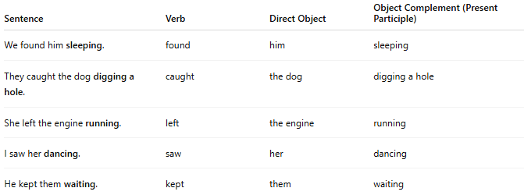
Sentence | Verb | Direct Object | Object Complement (Present Participle)
We found him sleeping. | found | him | sleeping
They caught the dog digging a hole. | caught | the dog | digging a hole
She left the engine running. | left | the engine | running
I saw her dancing. | saw | her | dancing
He kept them waiting. | kept | them | waiting

🔸 How to Identify:
# Source: AI Source: Provided by: [Data Path: Persons Table -> ID Column: 1, Name_En Column: Motasem Essam] -> From: [ChatGPT] on [8/4/2025]
Ask:
- “What did we find him (doing)?” → Sleeping
- “What did she leave the engine (doing)?” → Running
If the -ing form describes an action related to the object, it functions as a present participle object complement.

